EXAM QUESTIONS - BINARY NUMBERS

Binary questions can come in a number of different forms. Some will ask you to explain why binary is used, some will ask for a straight forward conversion and some will link the binary conversions to ASCII or Registers. Here are a few different examples of what to expect.

EXAMPLE QUESTION 1
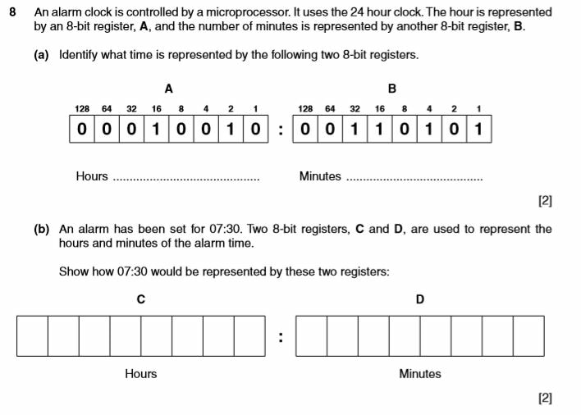
REVEAL ANSWERS

EXAMPLE QUESTION 2
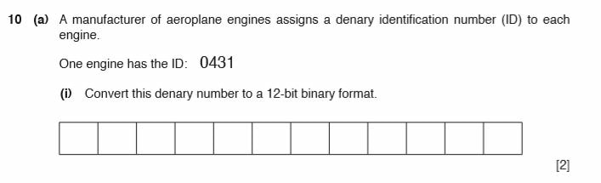
REVEAL ANSWERS

EXAMPLE QUESTION 3
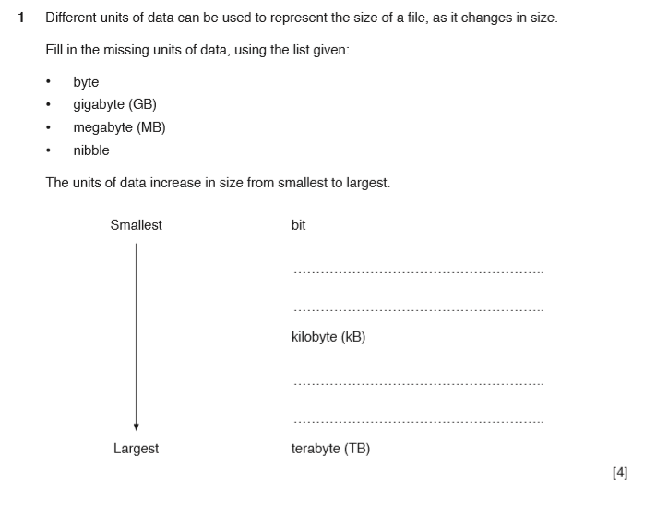
REVEAL ANSWERS

EXAMPLE QUESTION 4
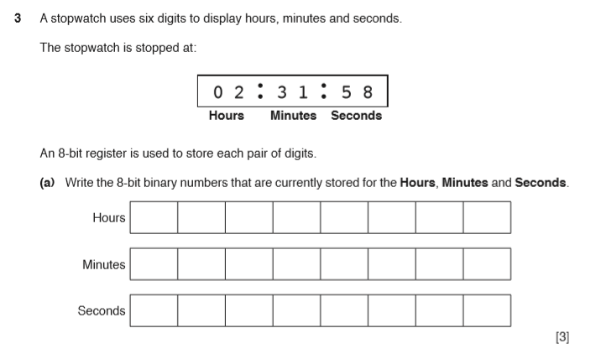
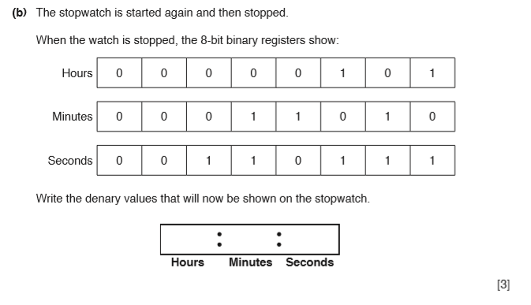

REVEAL ANSWERS

EXAMPLE QUESTION 5
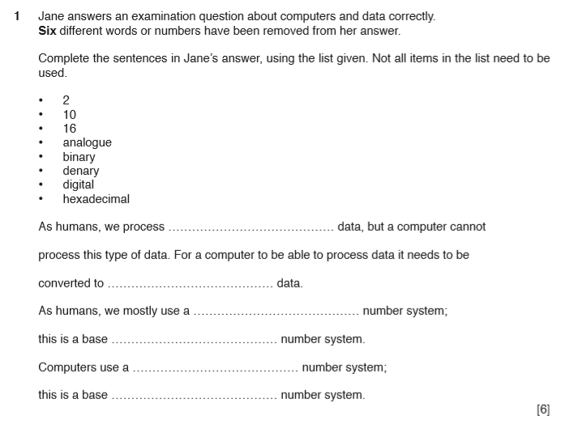
REVEAL ANSWERS

EXAMPLE QUESTION 6
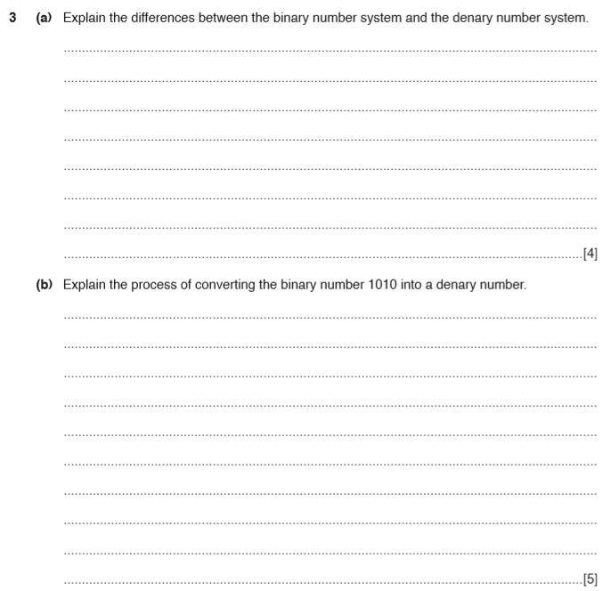
REVEAL ANSWERS

EXAMPLE QUESTION 7
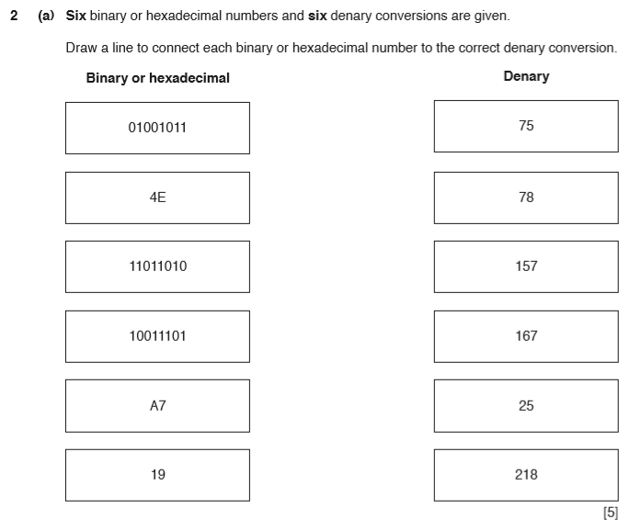
REVEAL ANSWERS

EXAMPLE QUESTION 8
